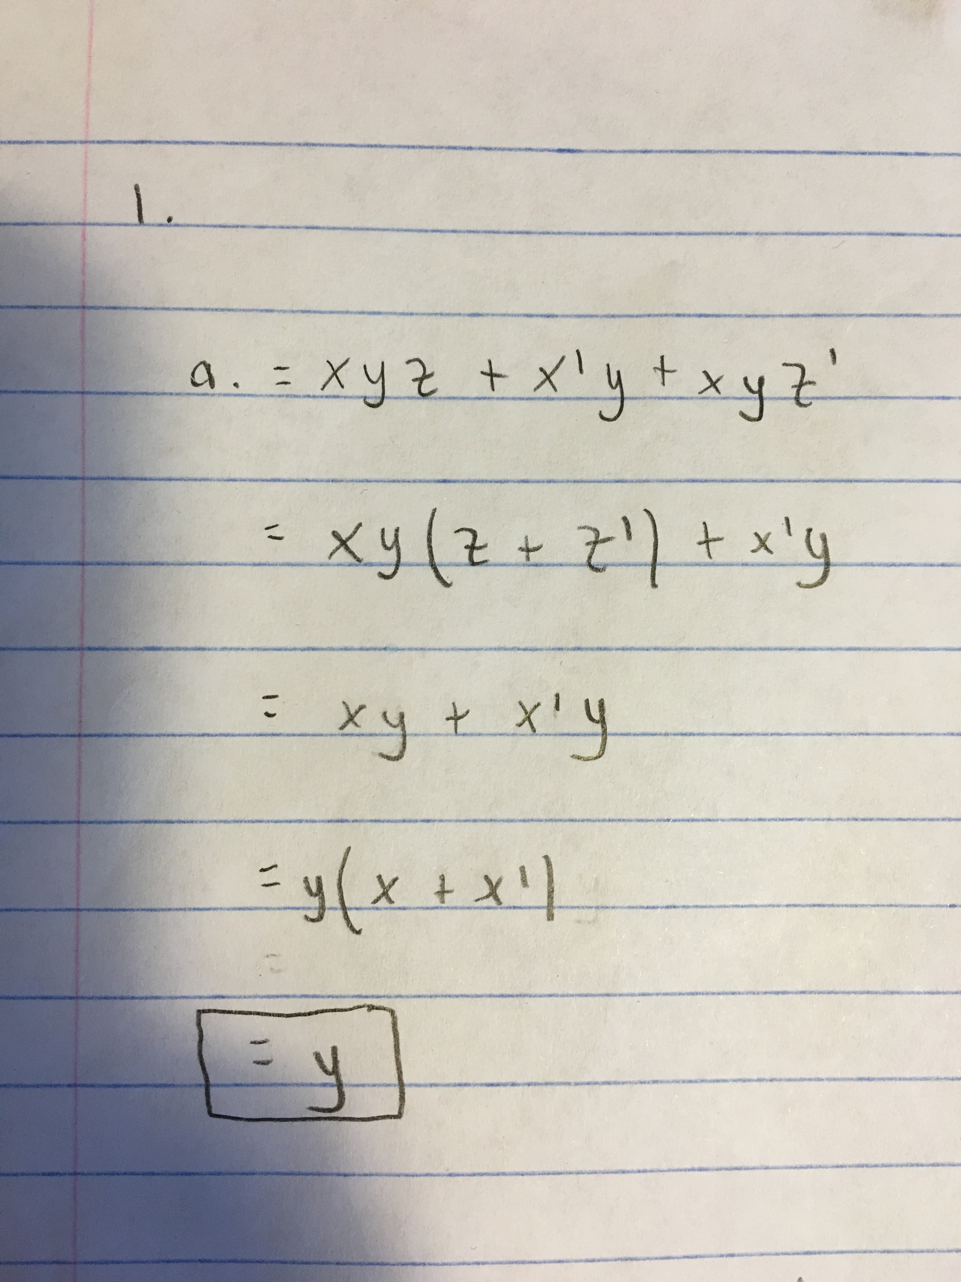
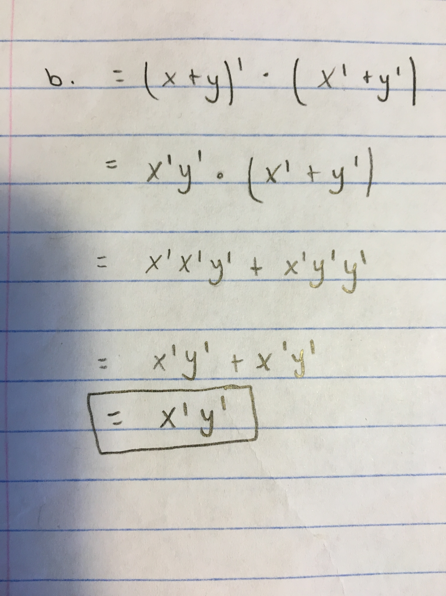
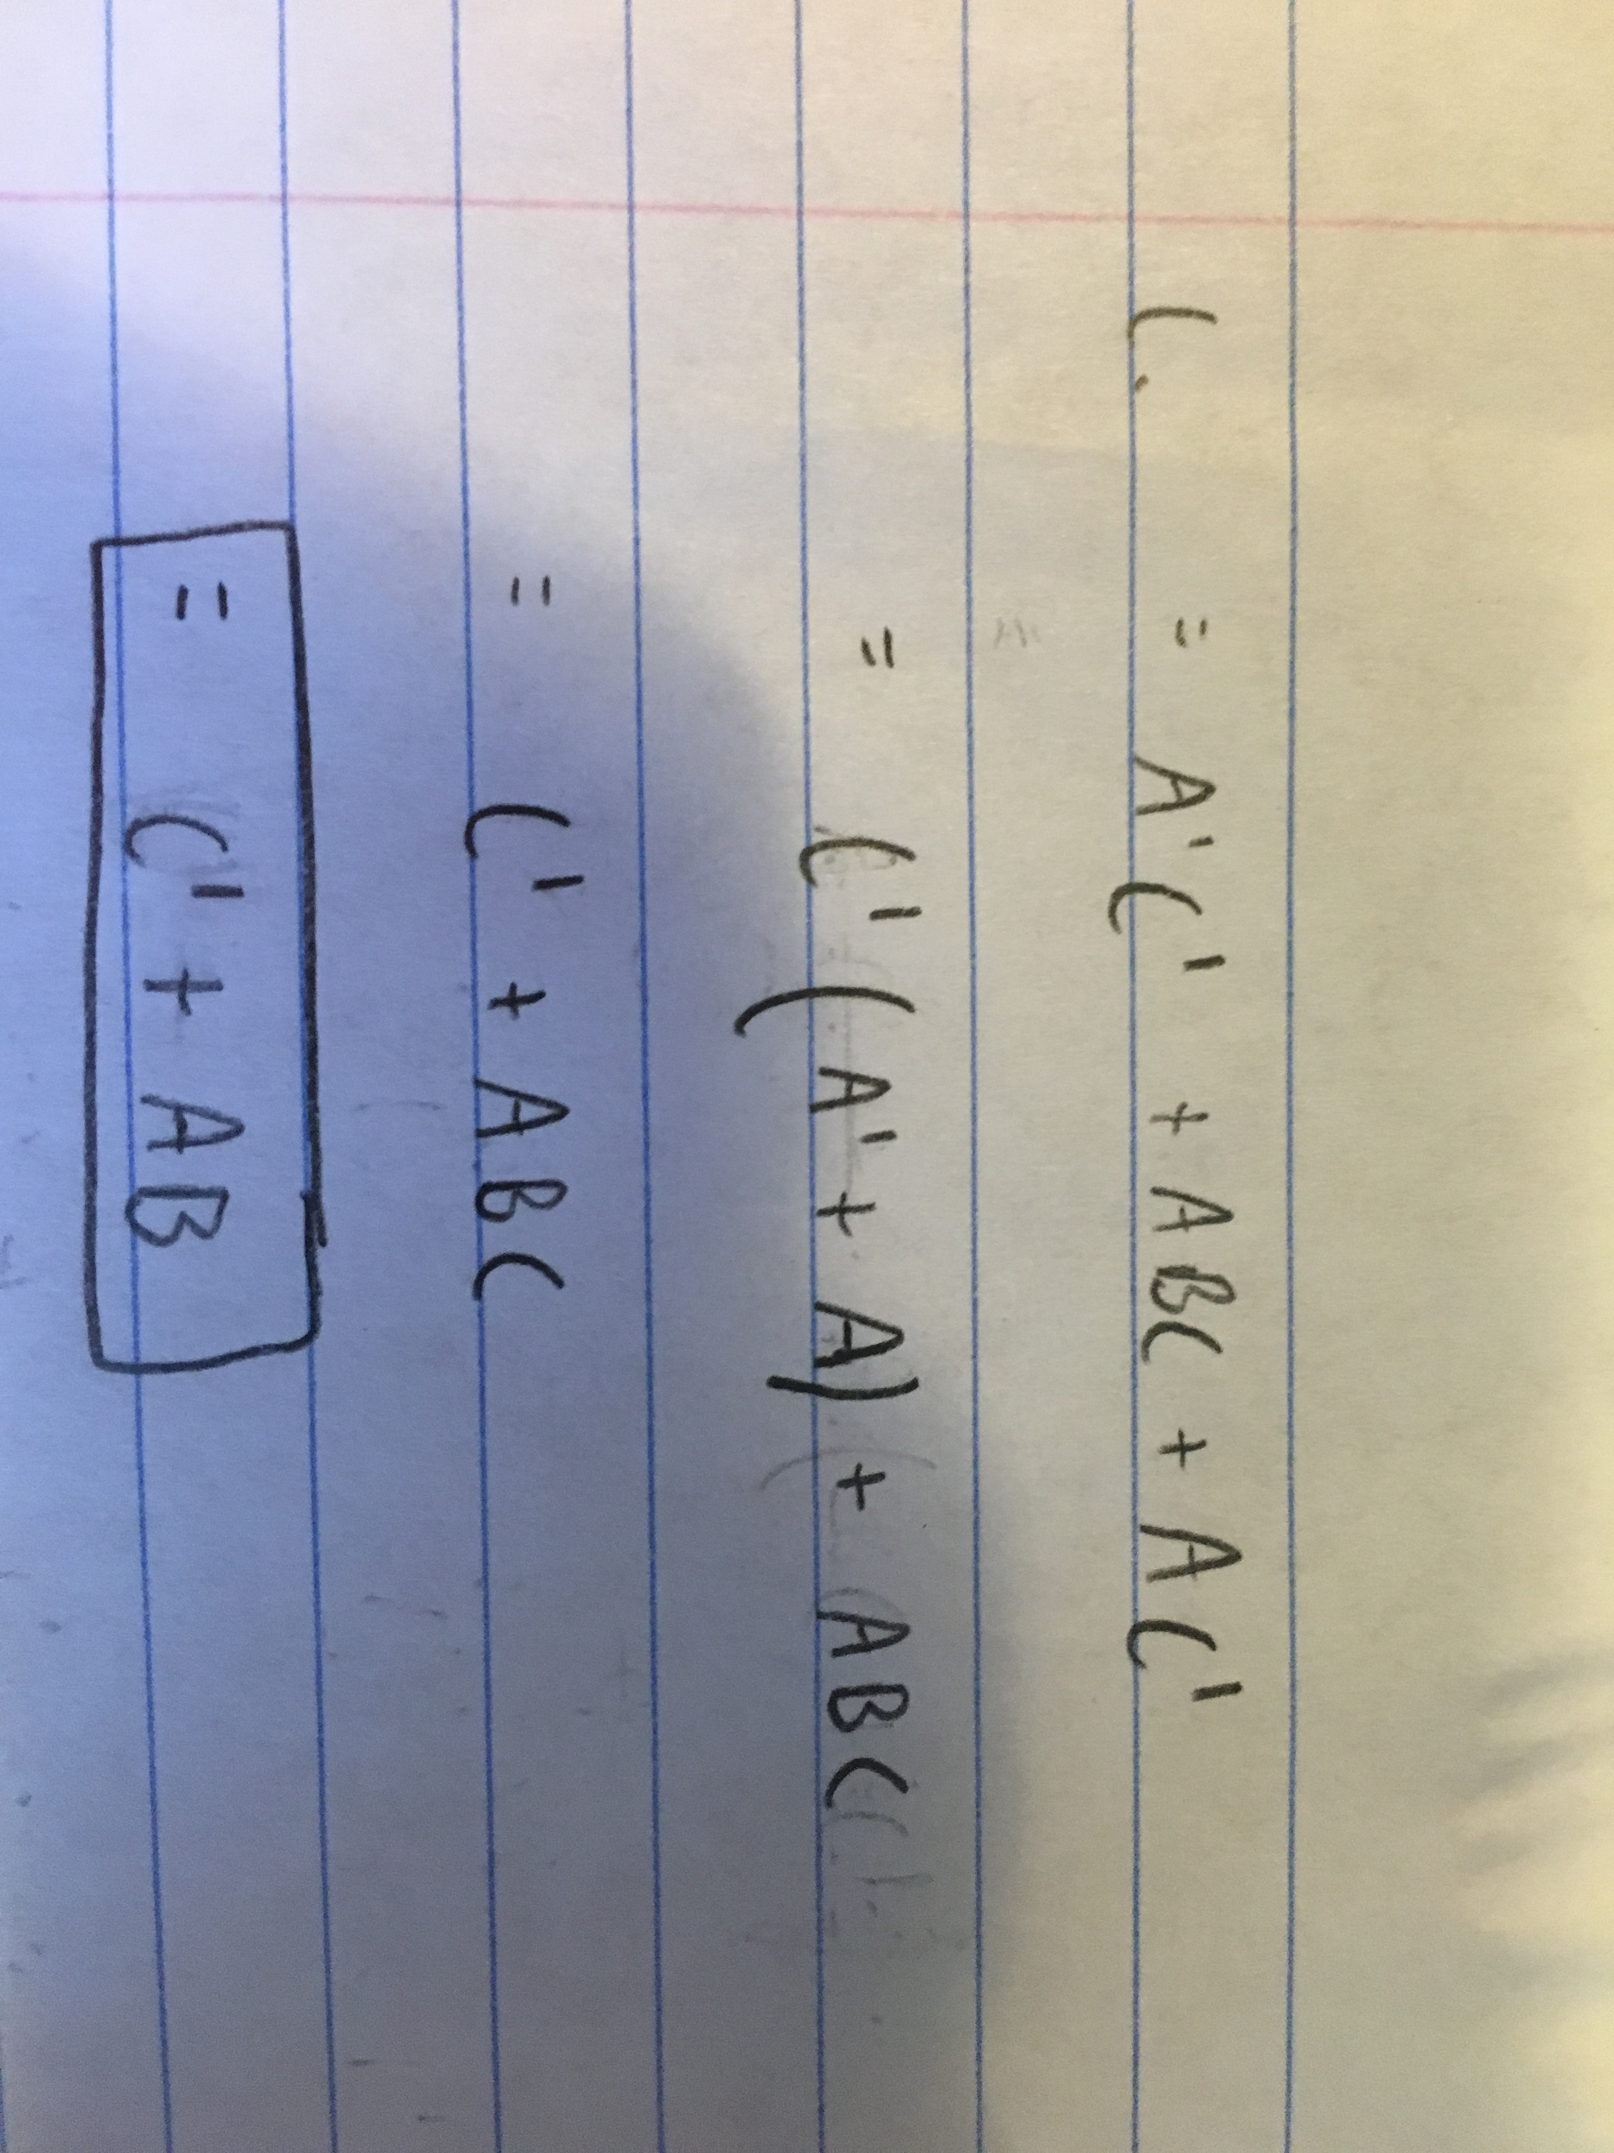

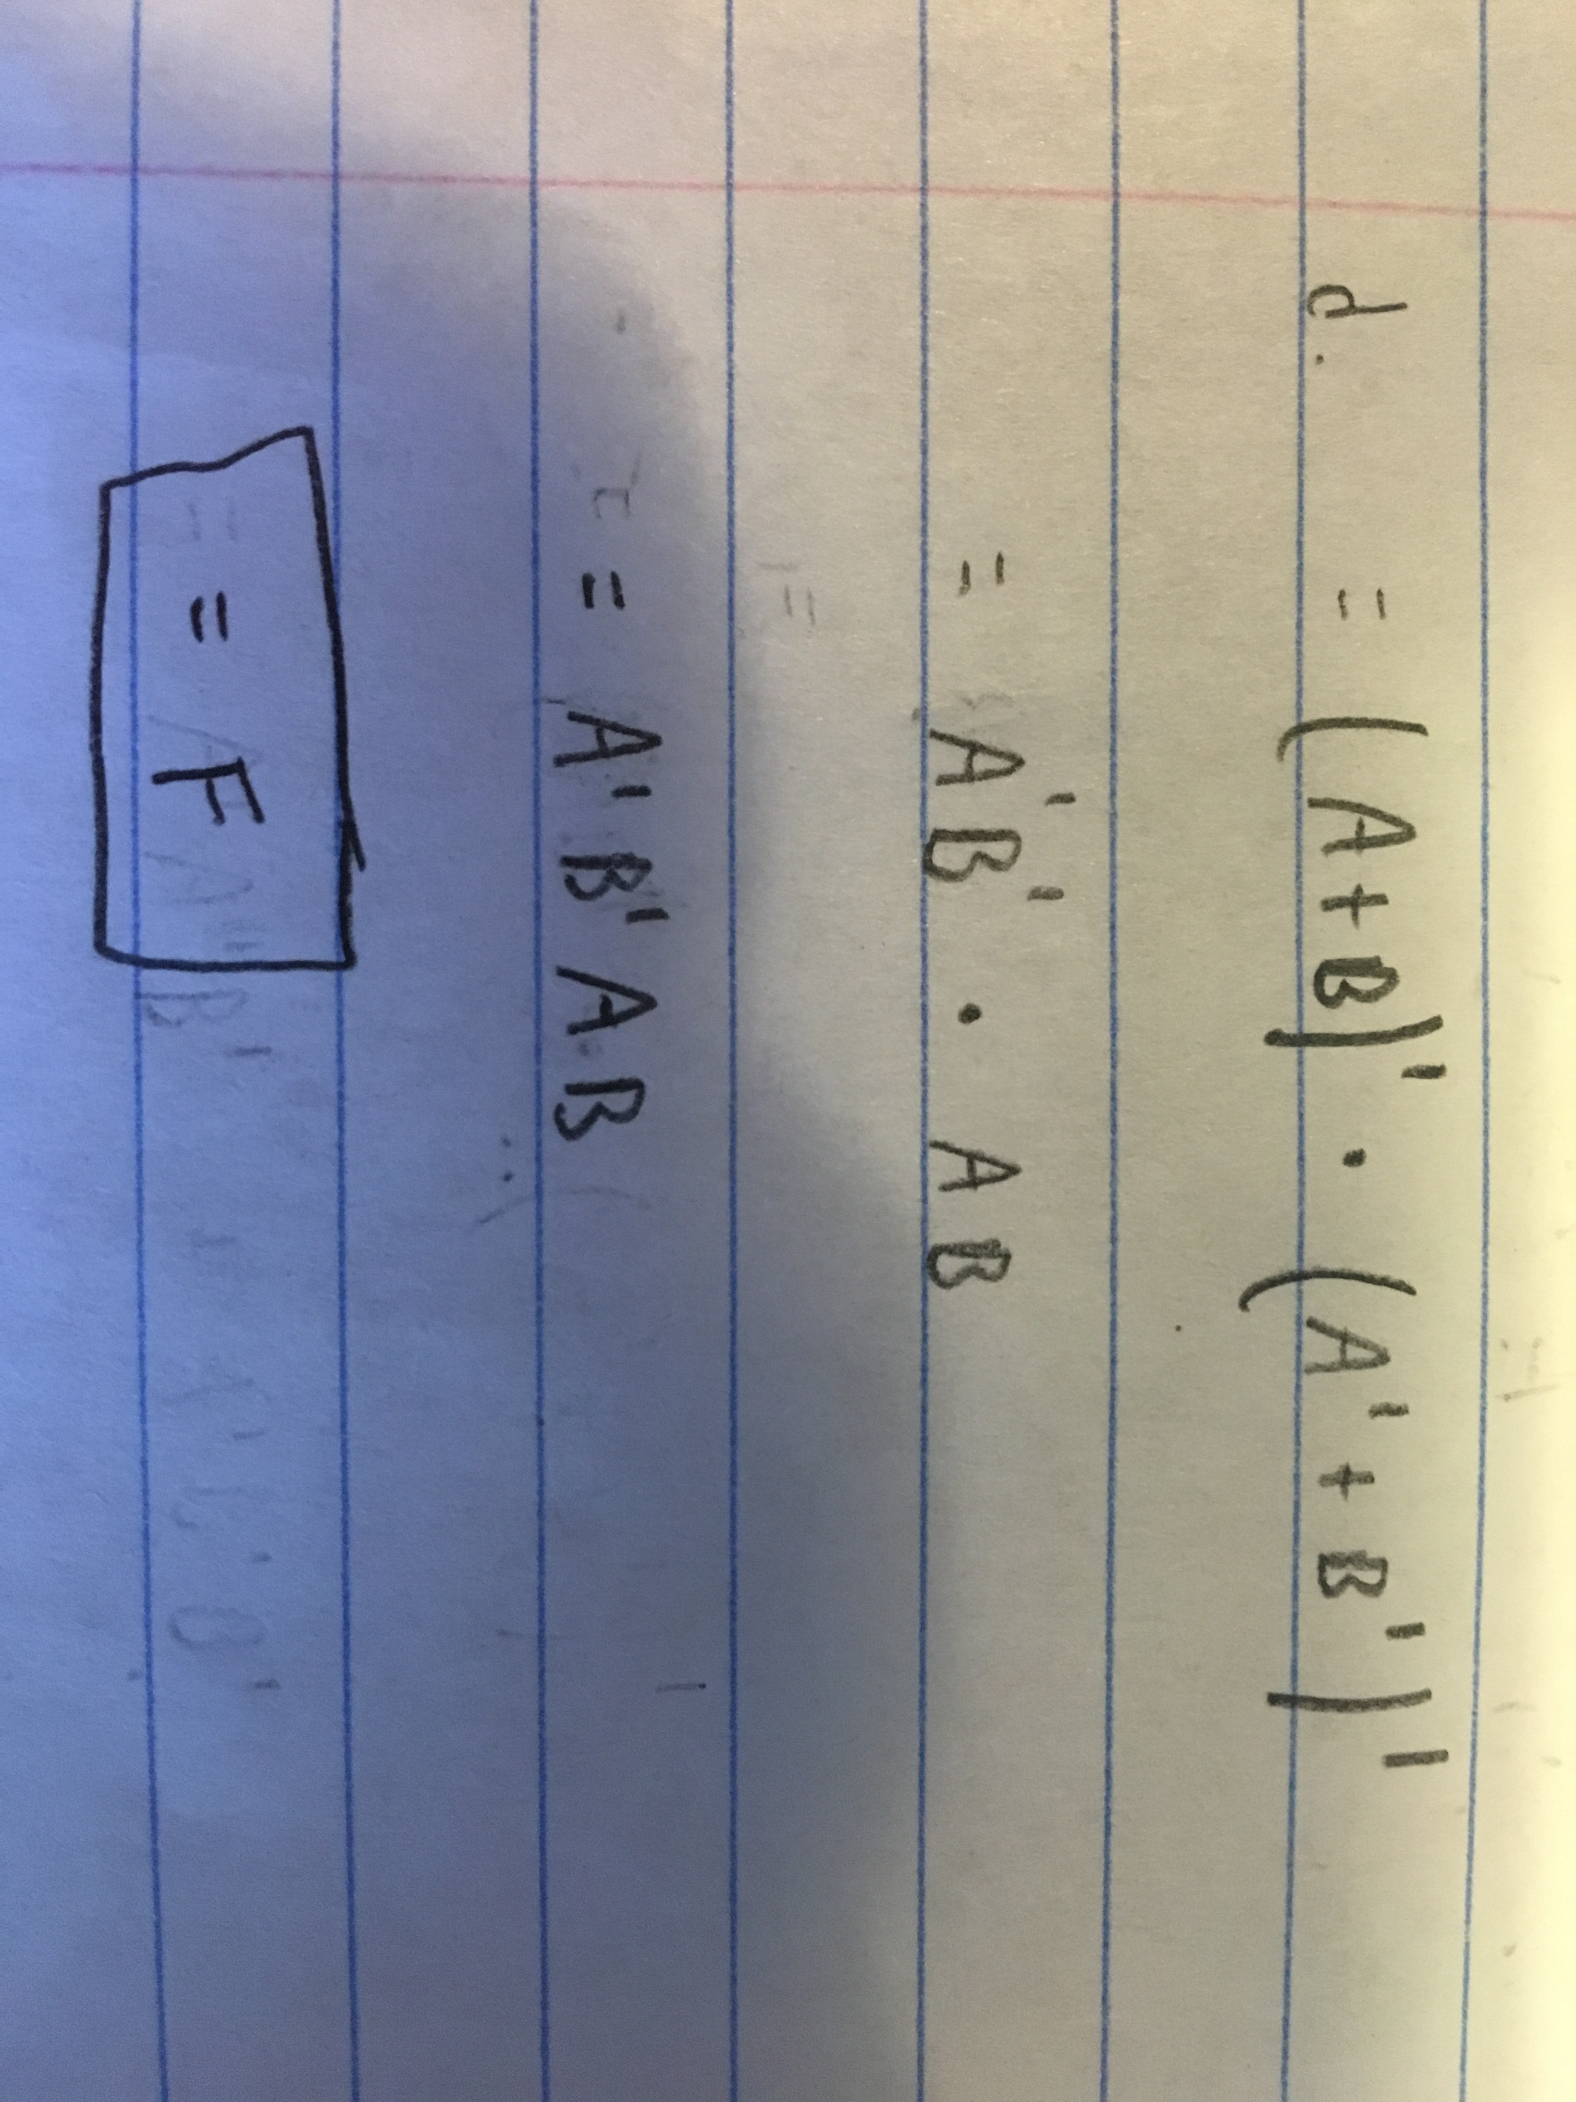

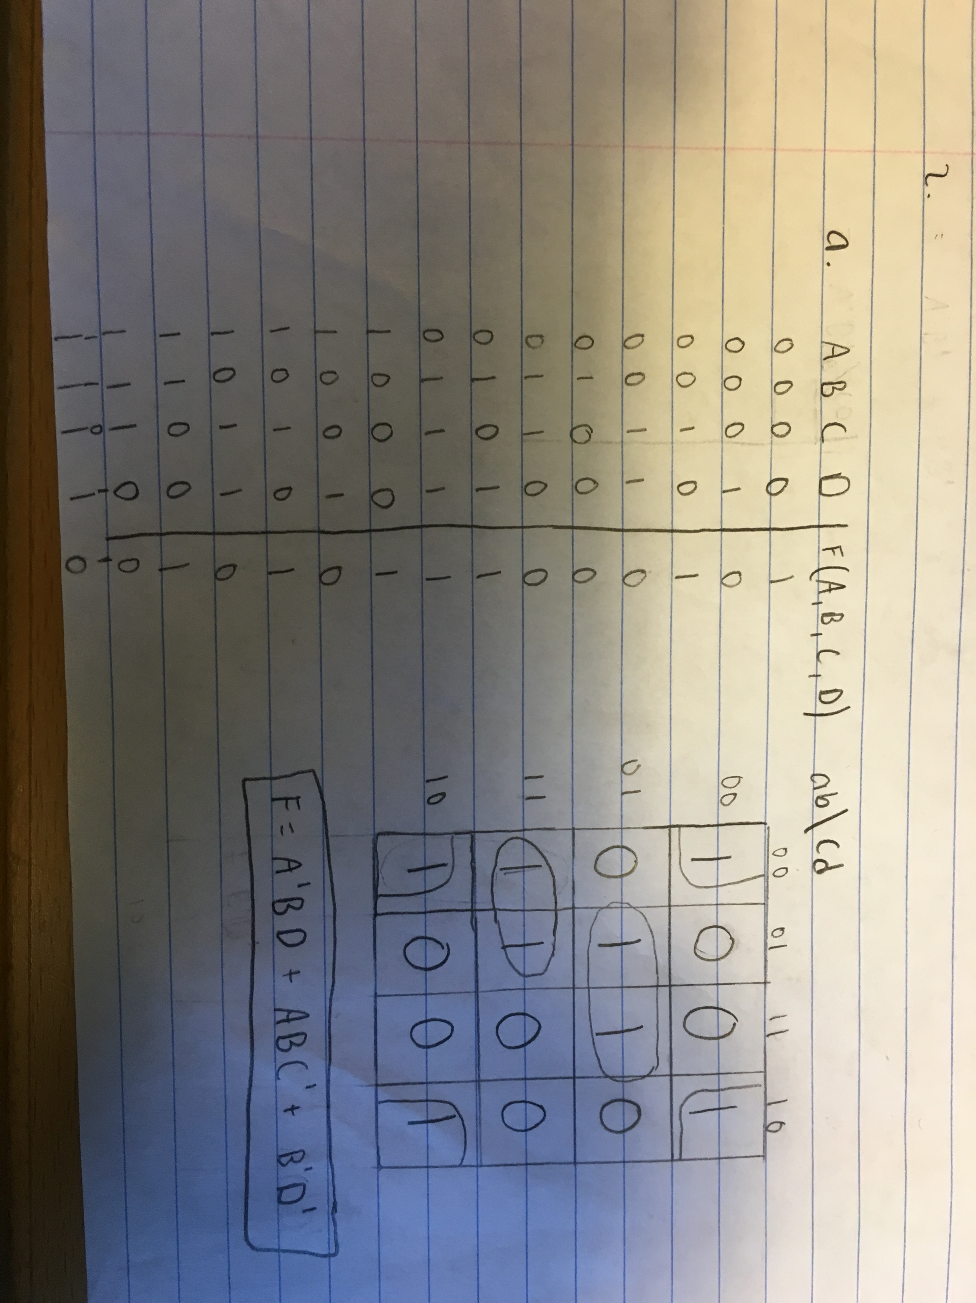

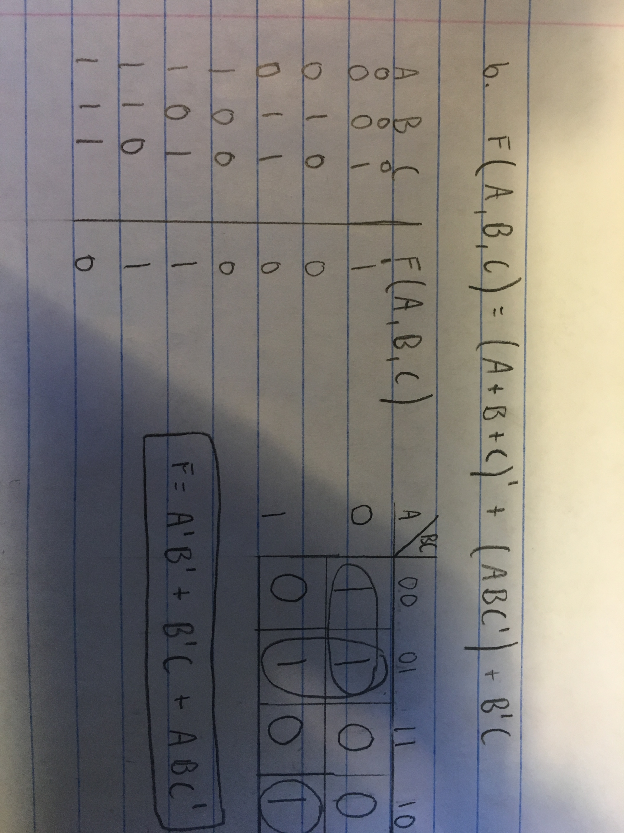

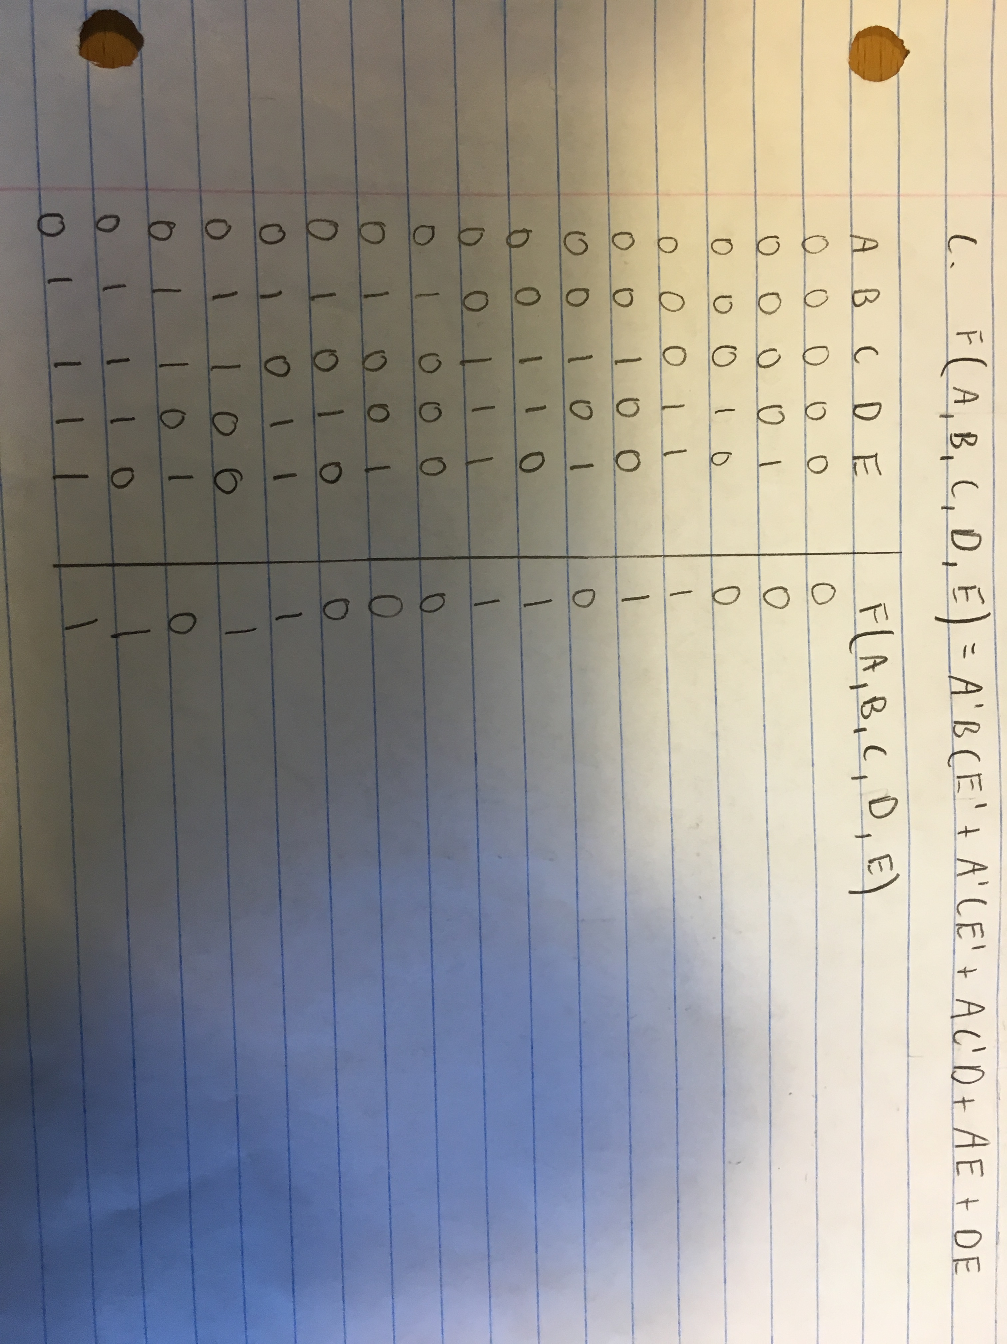

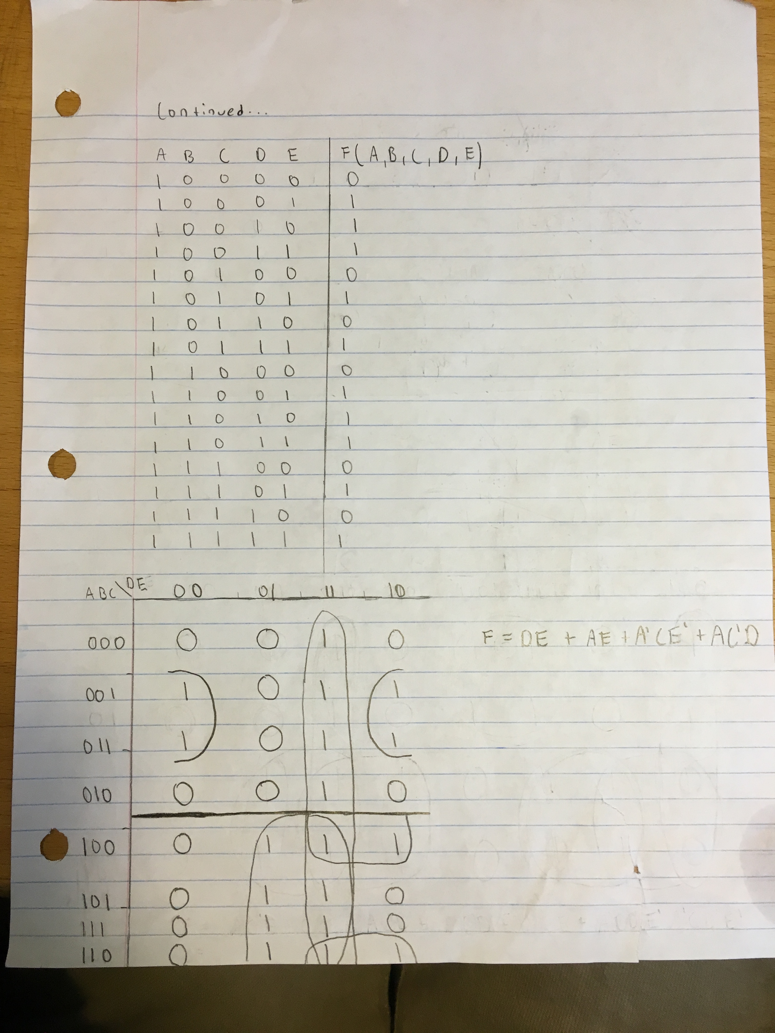
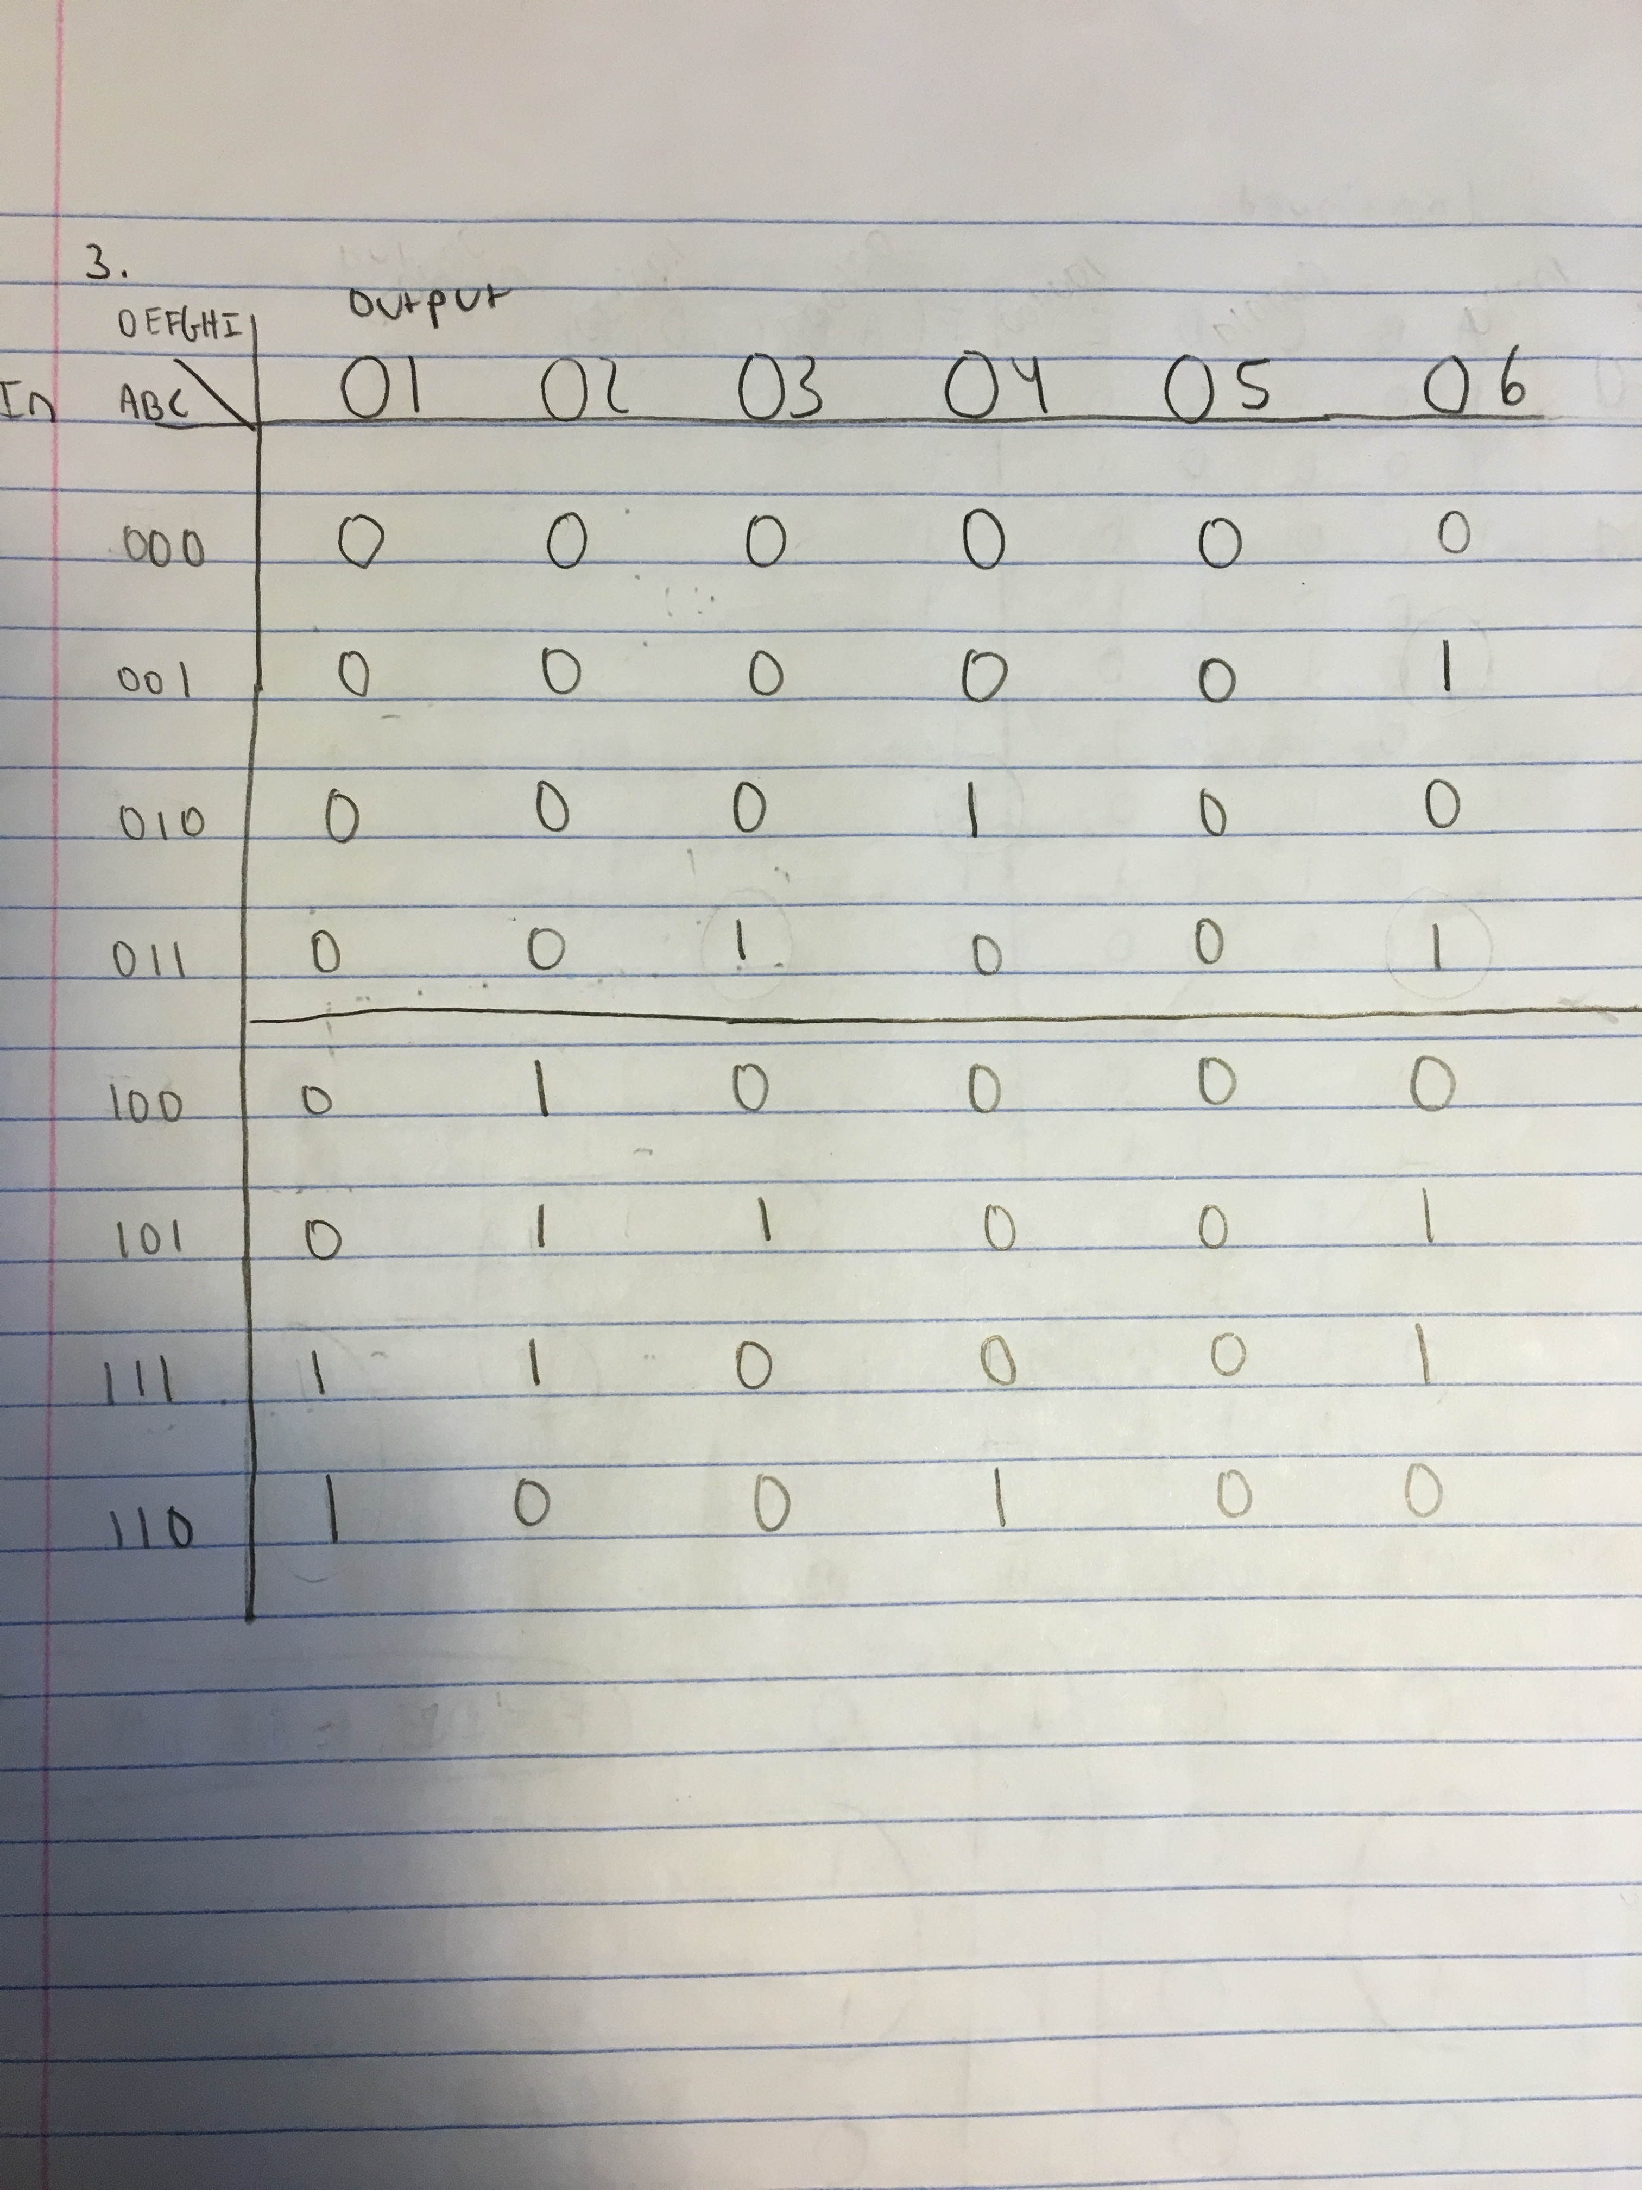

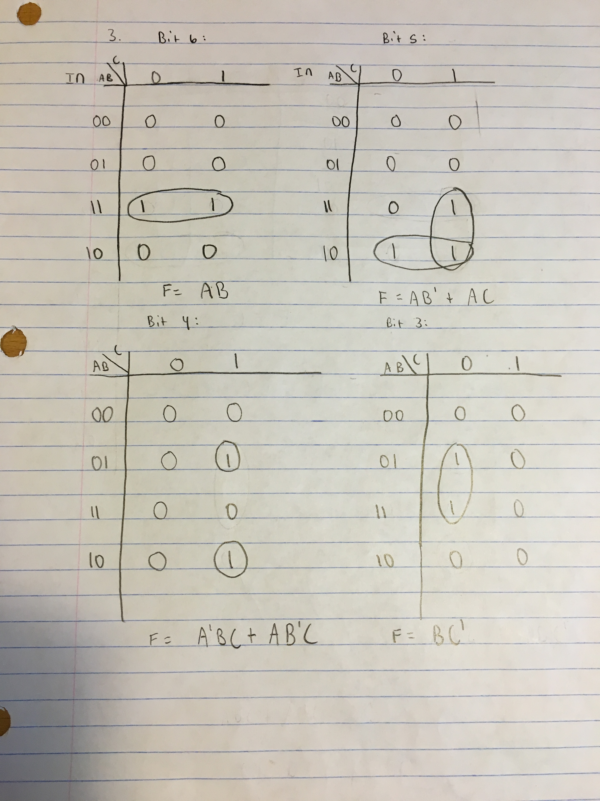
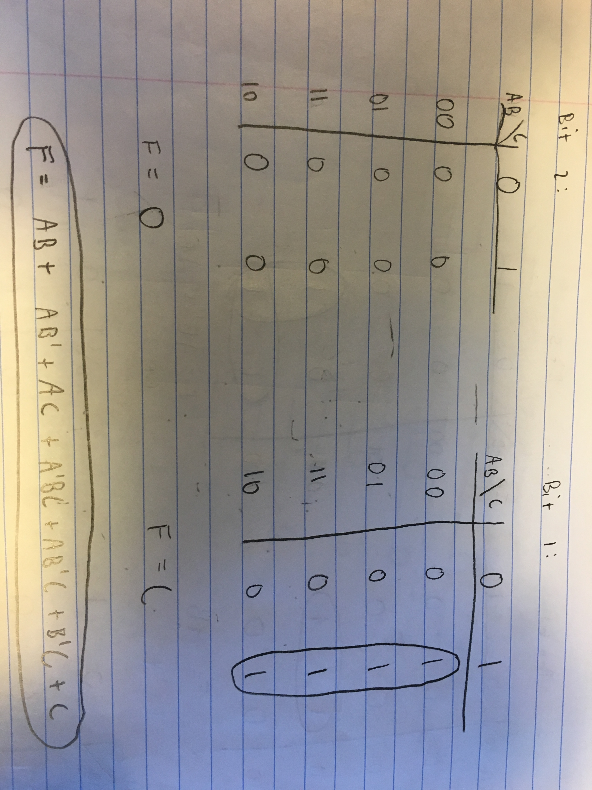

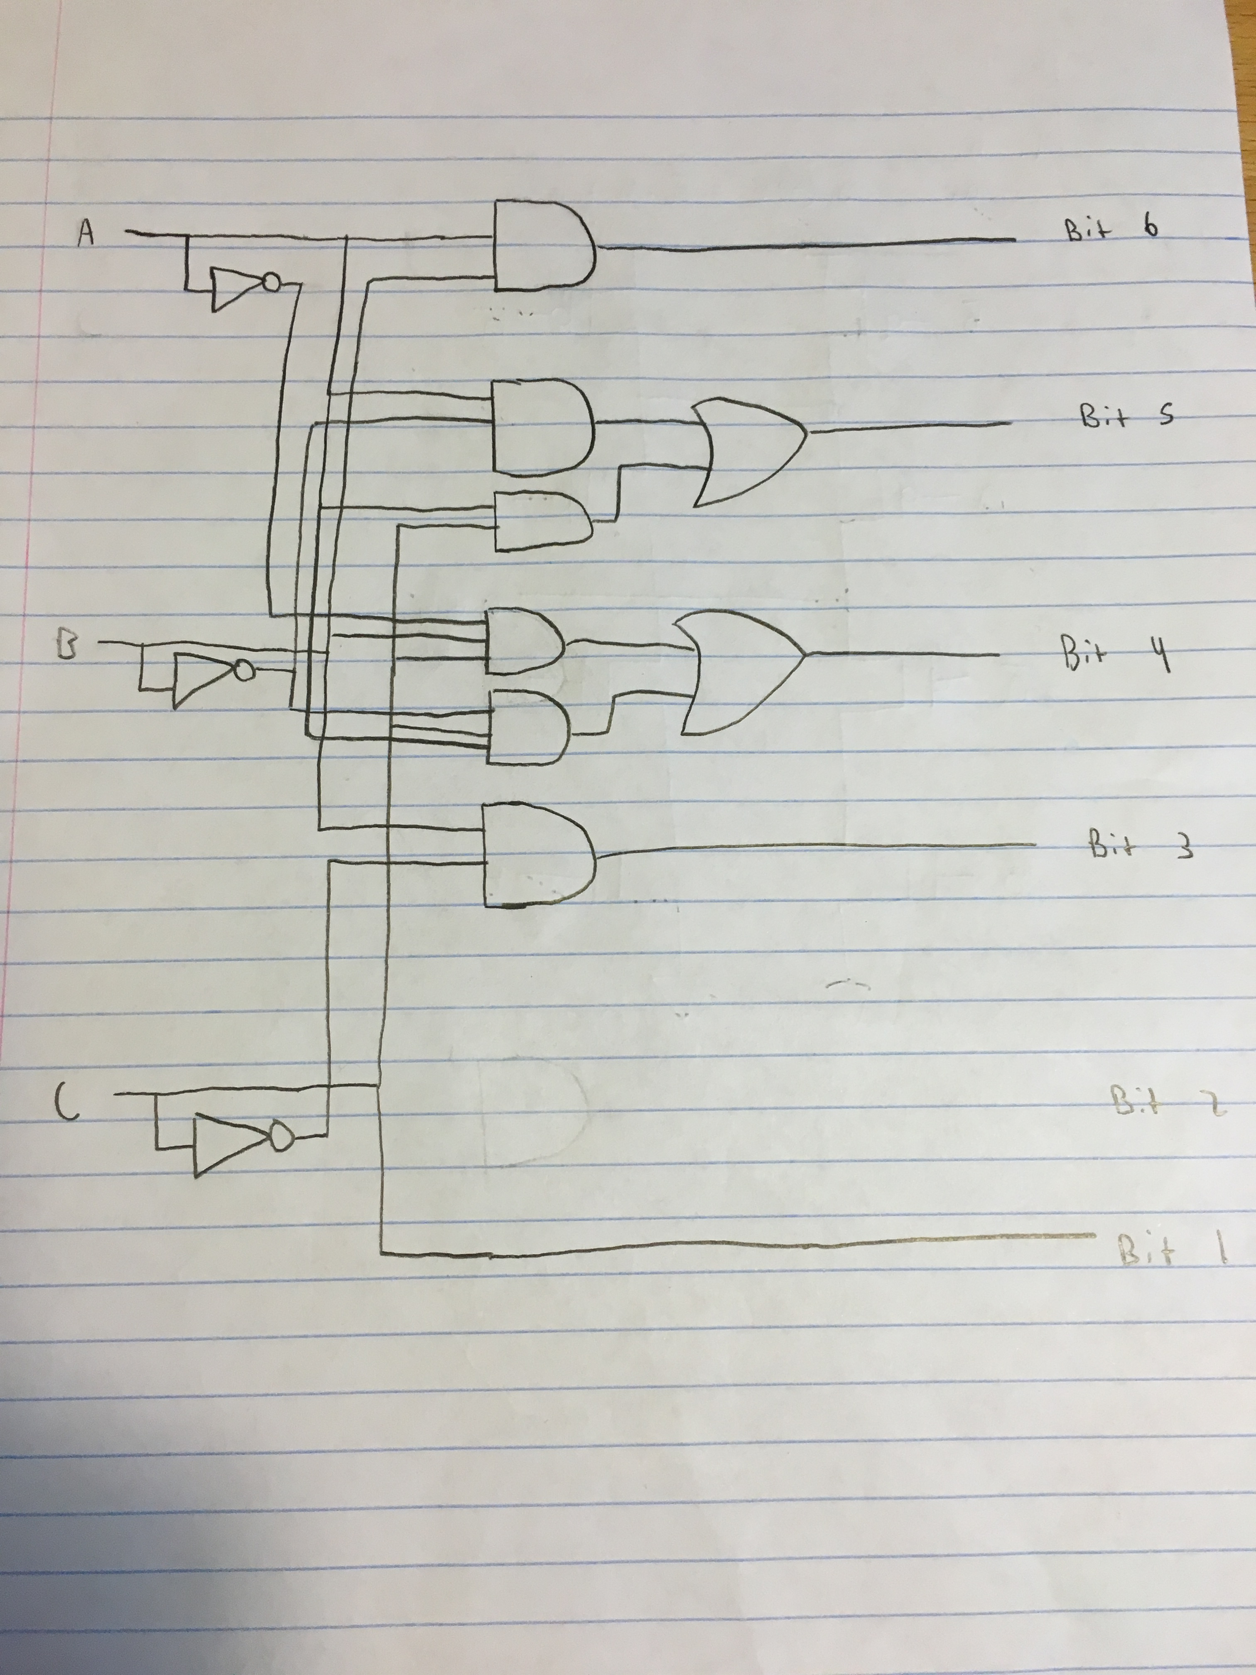
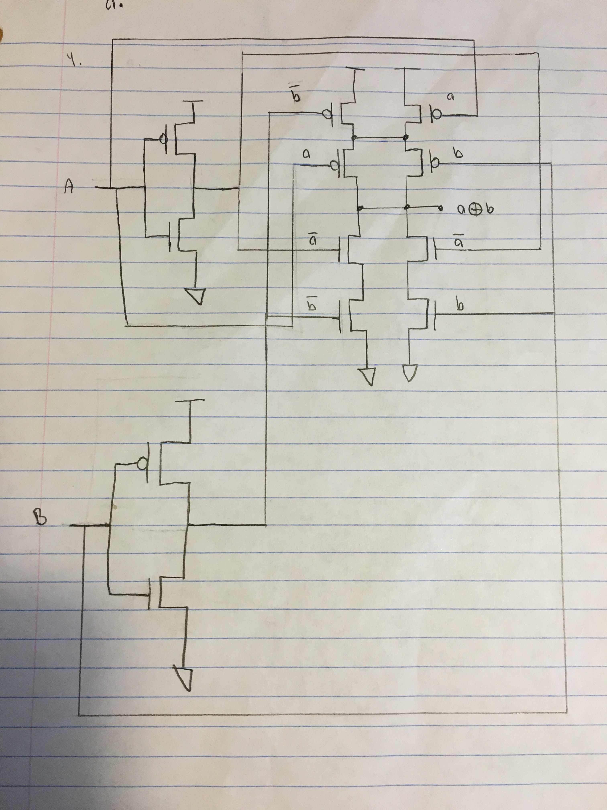
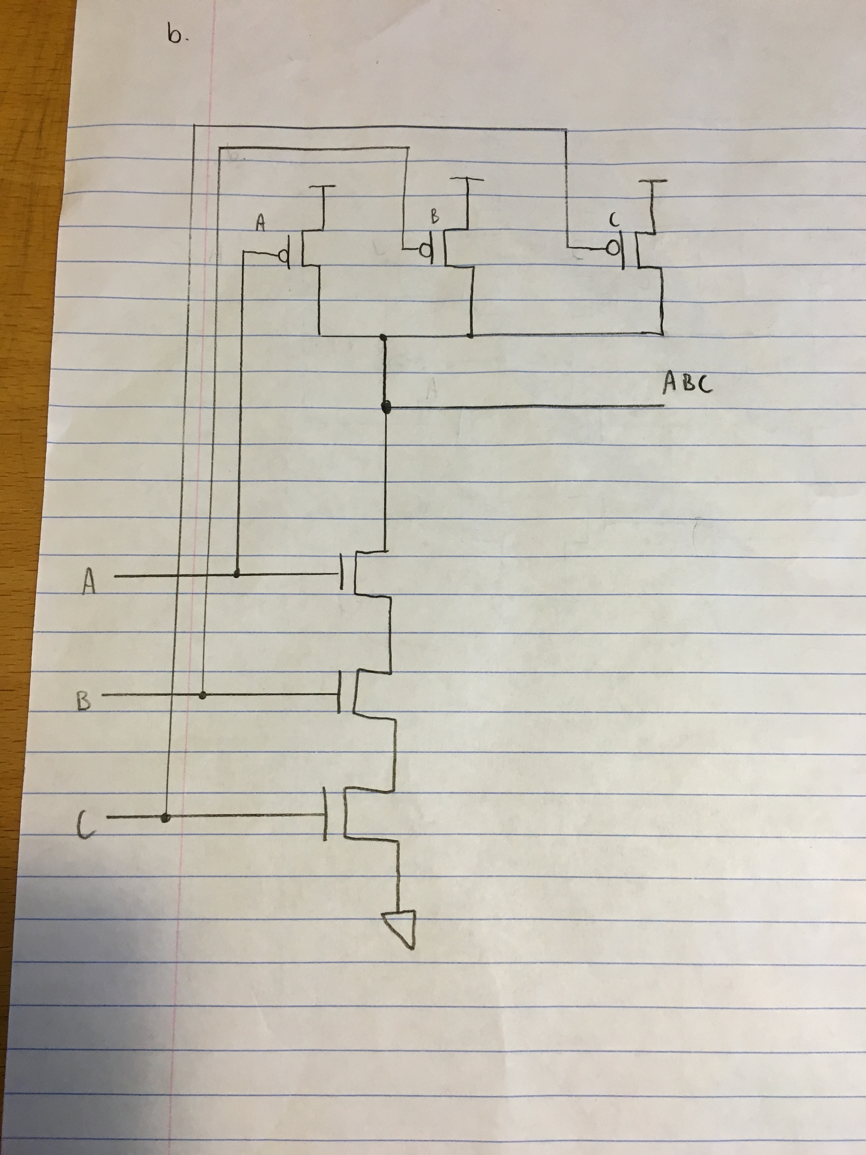
c.
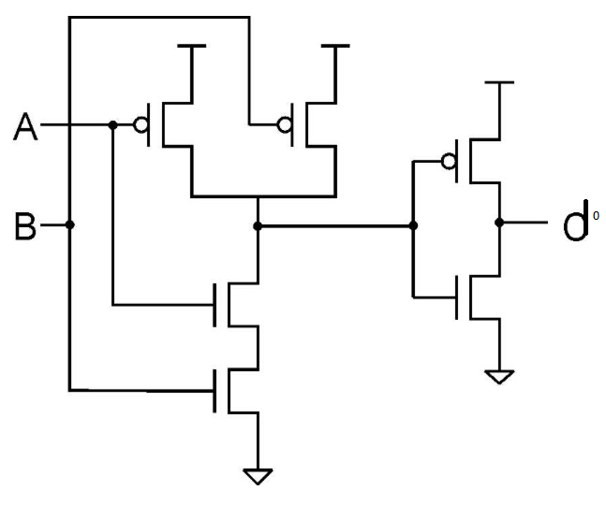

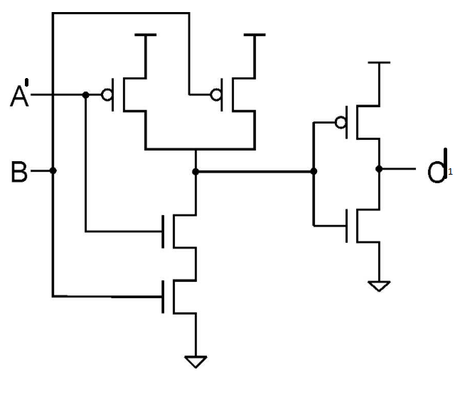

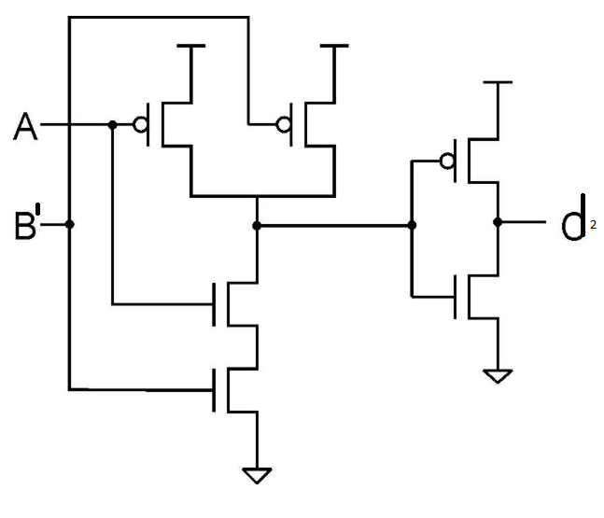

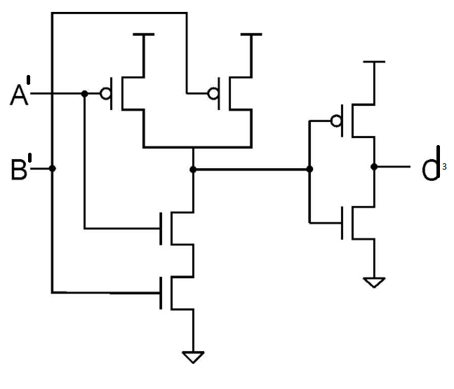

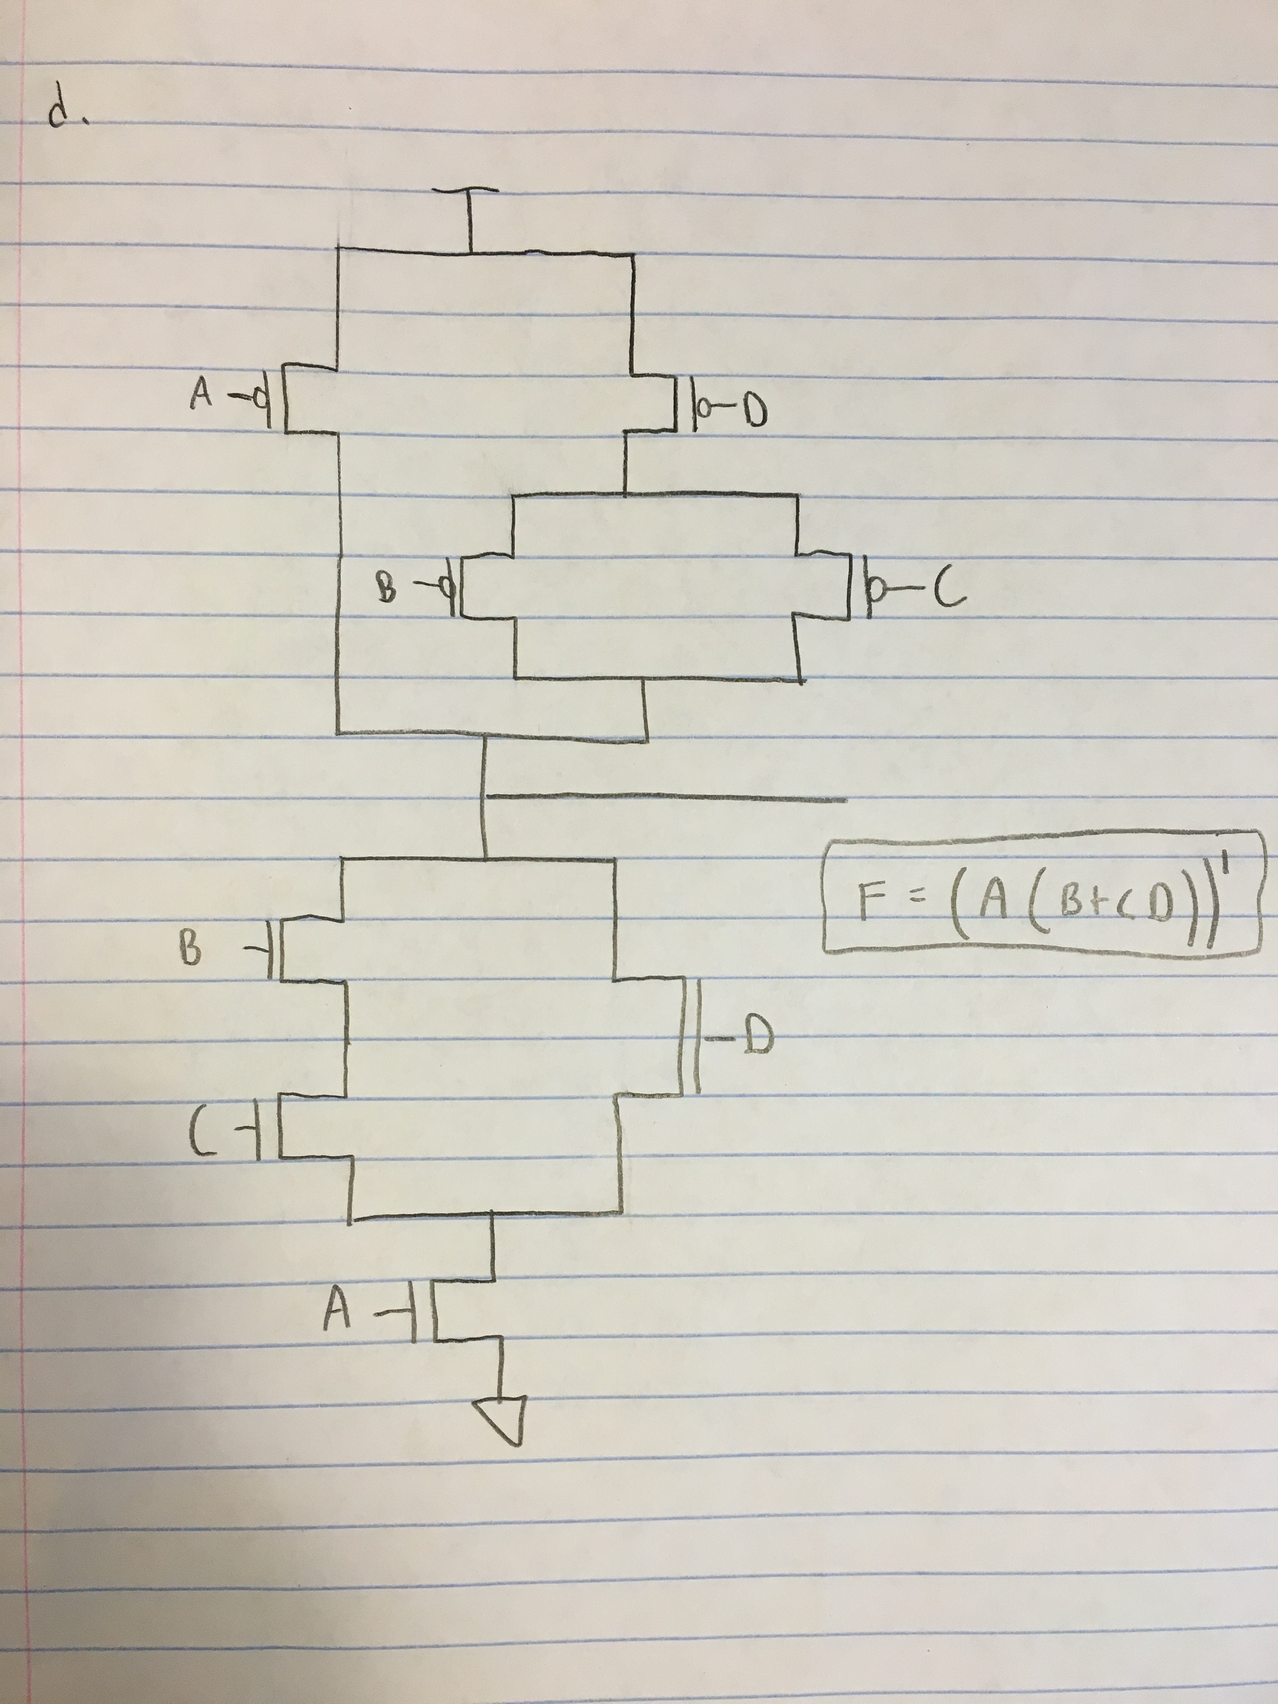
5.
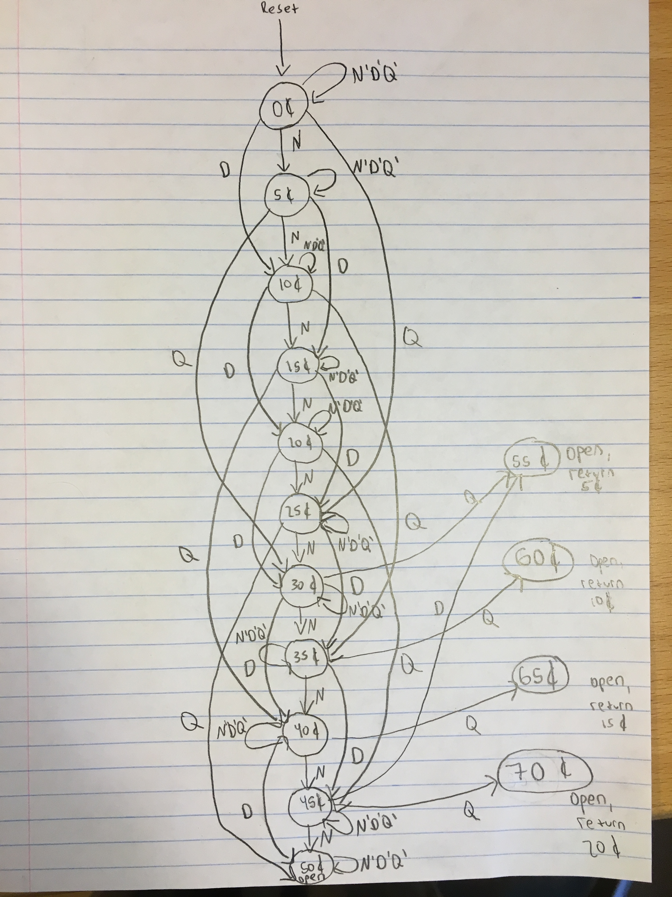

I designed it to be a Moore state diagram. The output is associated with the state. In this case, it is not associated with transitions or the inputs. One could have made the decision to express it in such a way, however. If it is in the state 50, 55, 60, 65, or 70C then the signal OPEN is set.

6.
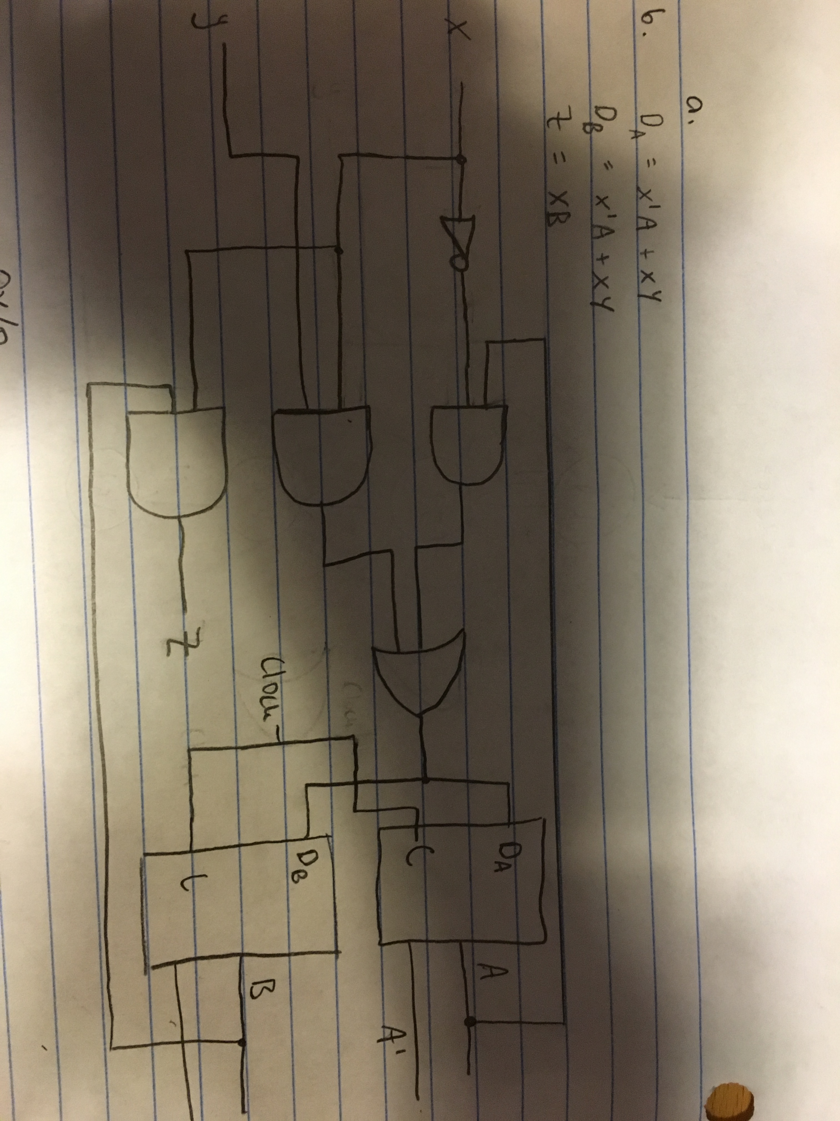

Present State | Inputs | Next State | Output

A | B | X | Y | A | B | z
0 | 0 | 0 | 0 | 0 | 0 | 0
0 | 0 | 0 | 1 | 0 | 0 | 0
0 | 0 | 1 | 0 | 0 | 0 | 0
0 | 0 | 1 | 1 | 1 | 1 | 0
0 | 1 | 0 | 0 | 0 | 0 | 0
0 | 1 | 0 | 1 | 0 | 0 | 0
0 | 1 | 1 | 0 | 0 | 0 | 1
0 | 1 | 1 | 1 | 1 | 1 | 1
1 | 0 | 0 | 0 | 1 | 1 | 0
1 | 0 | 0 | 1 | 1 | 1 | 0
1 | 0 | 1 | 0 | 0 | 0 | 0
1 | 0 | 1 | 1 | 1 | 1 | 0
1 | 1 | 0 | 0 | 1 | 1 | 0
1 | 1 | 0 | 1 | 1 | 1 | 0
1 | 1 | 1 | 0 | 0 | 0 | 1
1 | 1 | 1 | 1 | 1 | 1 | 1



